Click the Agmark’s app Icon

Welcome to Agmarks



After Load the app you have to select the language as you desired language.

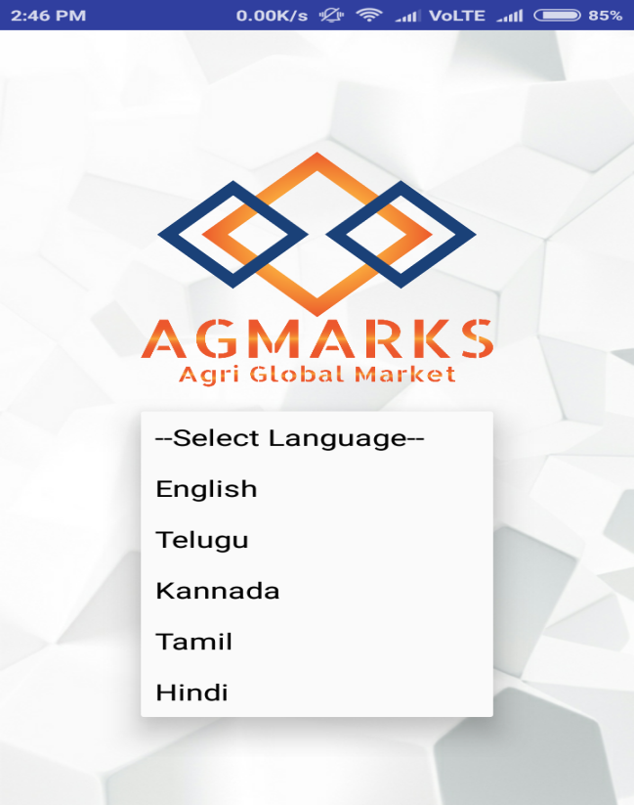

After you select the language in Agmarks entrance it will navigate to the Agmarks tile page and it shown as the bellowed Image

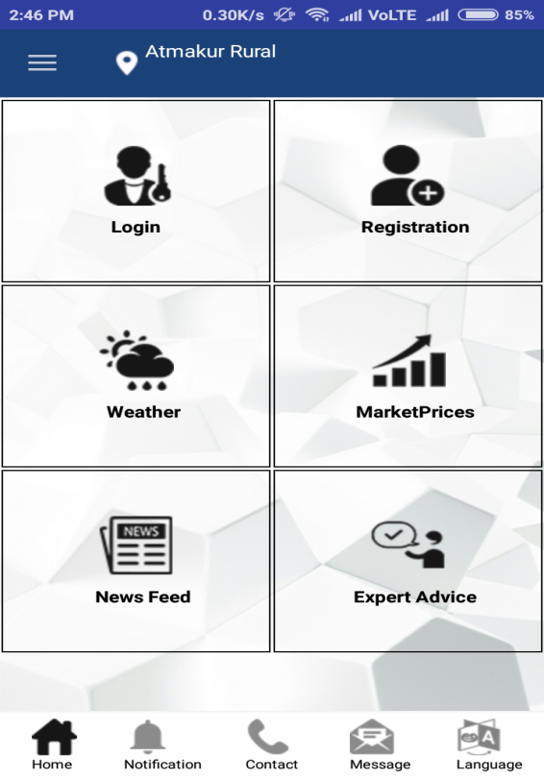

Here you have to be user of Agmarks then only you have access more particulars in modules, you need to be register please click the Registration Button in the above Image as shown then it will navigate to module’s page like as bellow

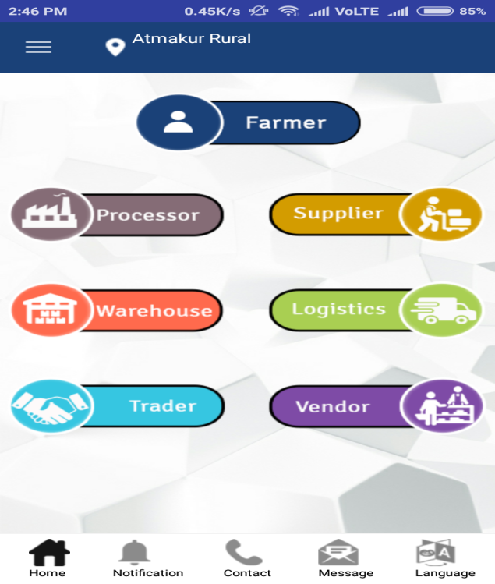

Here I describe in detail how to register different registration process, I choose to register as **Farmer**

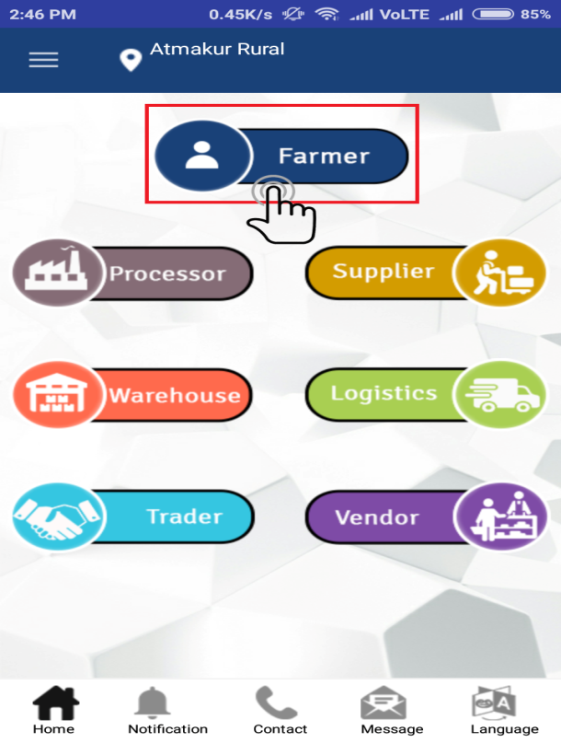

Click the Farmer menu icon in the above screen then It will take to the next page as asking Mobile Number and Pincode

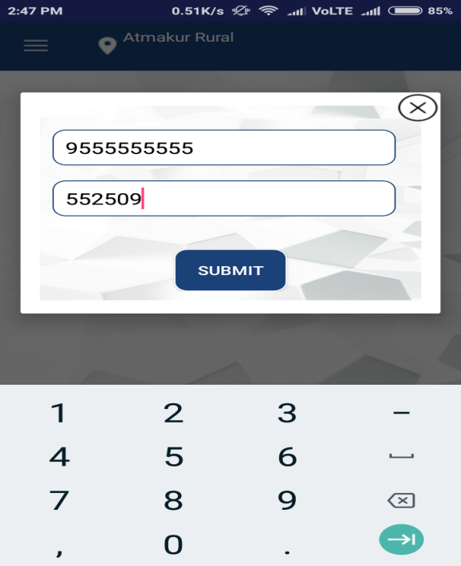

Enter the Mobile number and Pincode and submit then only it will navigate registration form there you may fill all the valid details in the Farmer registration form

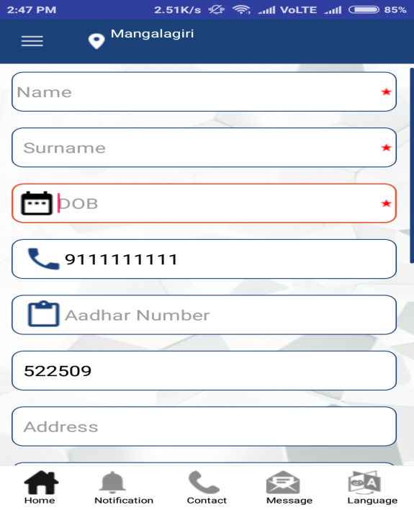

The registration form will continue screen…

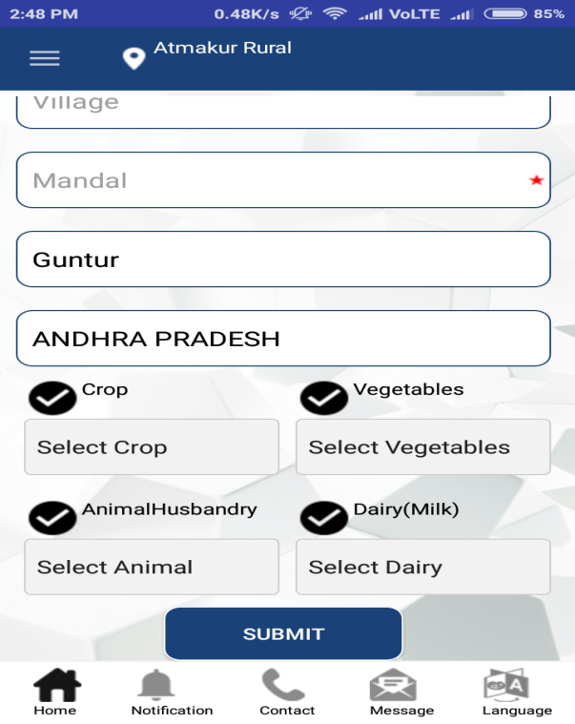

when you have enter all valid details while submit form then you receive response message as registered successfully.

Now, we see another registration process as in order say is **processor registration** form

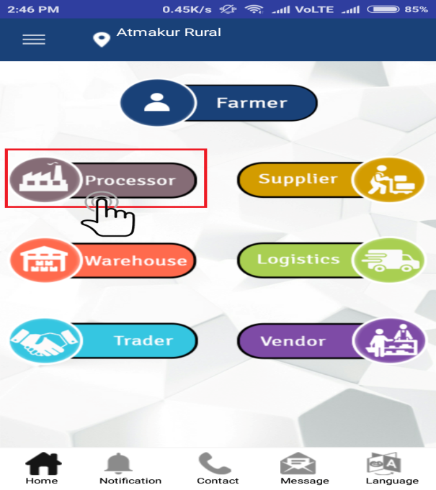

display the popup when you click processor Icon there you can enter valid mobile number and then submit.

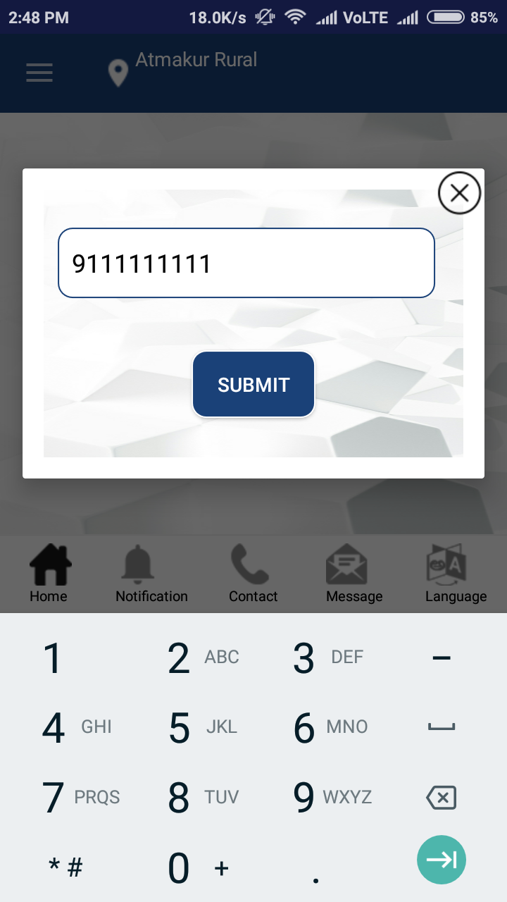

After you submit the mobile number there you will get the processor registration form and here we have two ways of registration and we can choose one of either company or Individual.

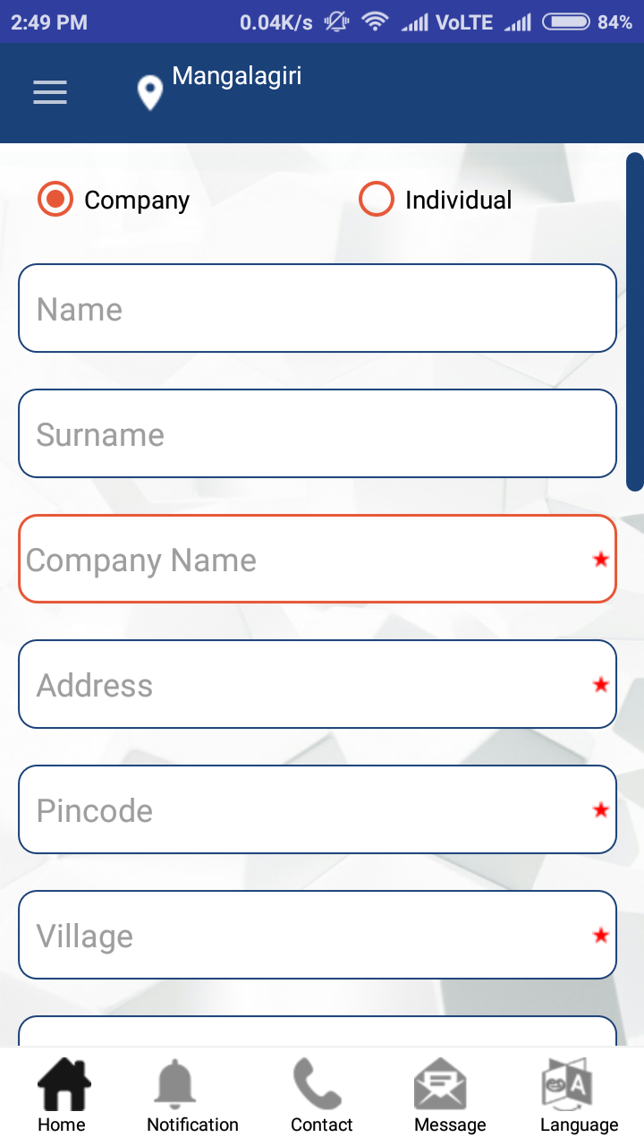

The registration form will continue screen…

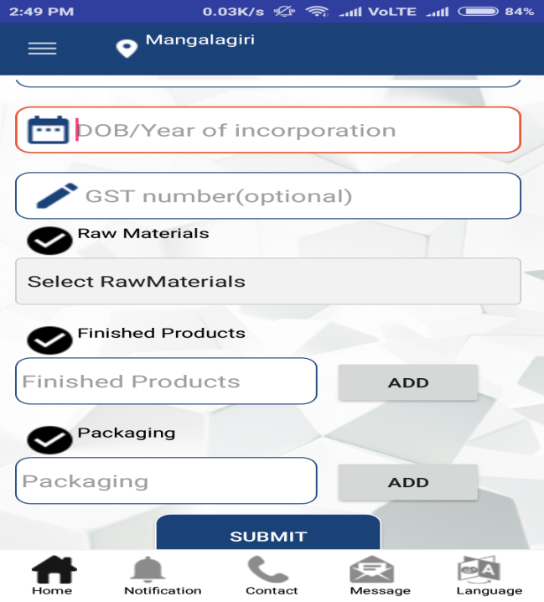

In the above pic, we selected as company there may filled all the valid details and select 2 raw materials then add 3 finished products and 3 packaging there we can submit all the valid info to register, after complete the registration you receive a OTP and verify it automatically will get response message “registered successfully”

Same process will continue in the processor as Individual also.

Here we see the registration process of **Supplier’s registration** in detail please click on Supplier’s Icon

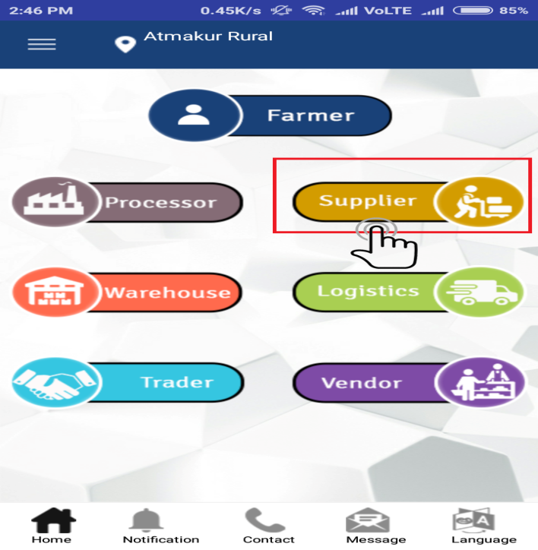

When we click on the Supplier registration button it will navigate to the another page of supplier’s registration form there you have to enter mobile number and then click submit

. 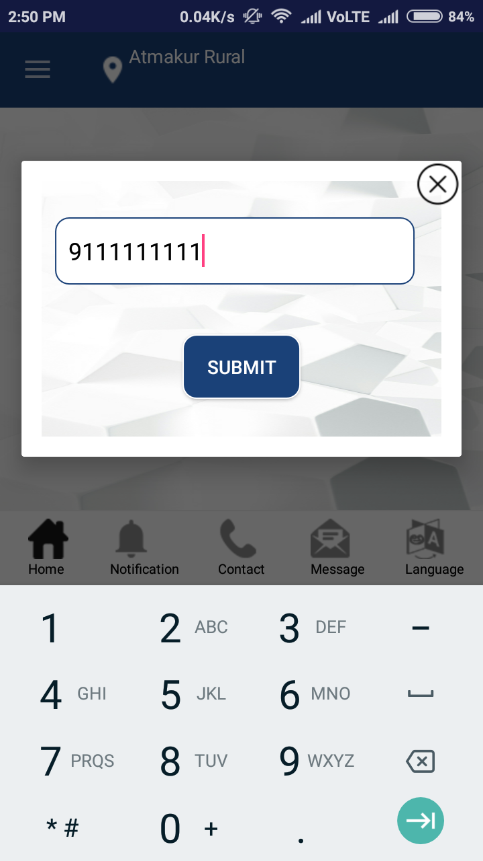

Here I choose to register as company in Supplier registration form.

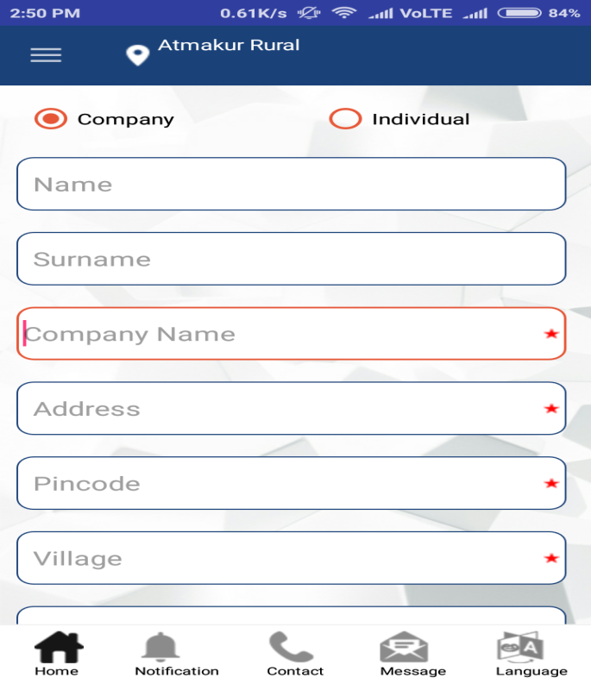

The registration form will continue screen…

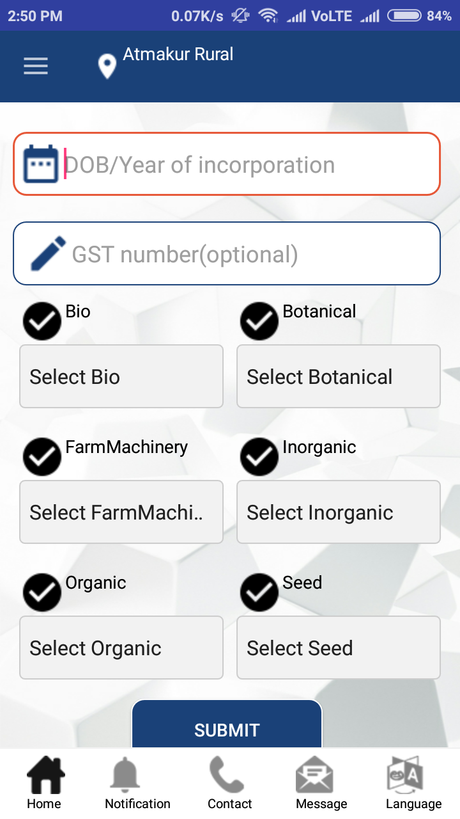

In supplier registration form we wish to select unlimited selectee’s in the fields of Bio, Botanical, FarmMachinary, Inorganic, Organic, Seed then click submit button there you receive OTP and verify it automatically get a message “Successfully Registered” if you given a valid details.

Same process will continue in the Supplier in Individual also, try this.

We see another registration process of **Warehouse registration** process please click on the Icon Warehouse in Agmarks tile screen

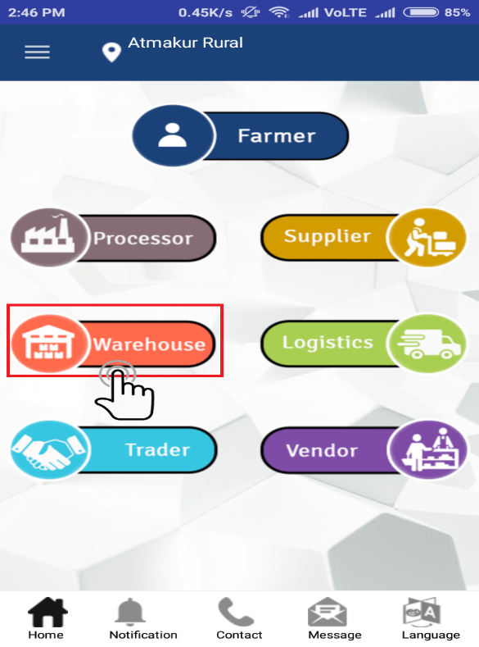

After click on the Icon Warehouse you will be navigate to registration of entrance page it is asking for the mobile number and then submit

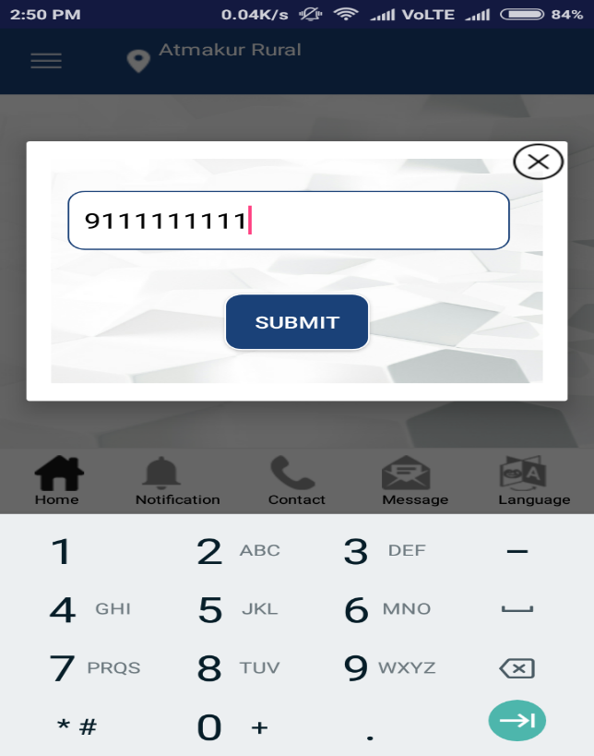

It will take you to registration form in the **Warehouse** registration so you may fill all the valid details to registered.

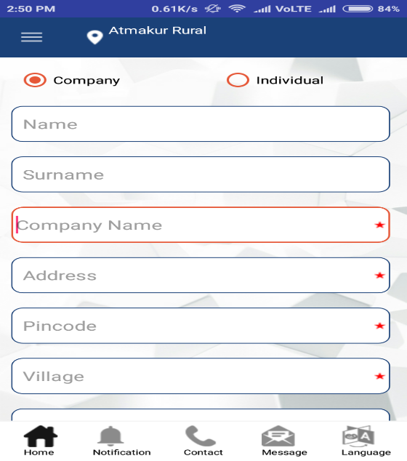

The registration form will continue screen…

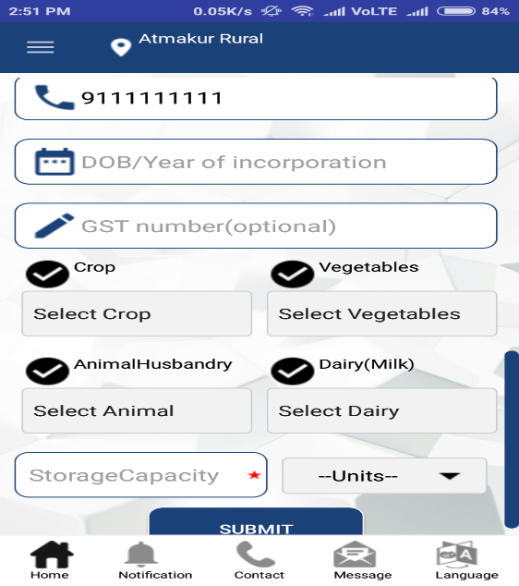

Here we can select unlimited selectee’s in the registration form fields like crop, vegetables, Animal Husbandry, Dairy and storage capacity is mandate here you can declare capacity and select the dropdown units are in Quintal or Tones after fill all the valid details to register then click submit registration form, there will you receive a OTP and verify it automatically get a message “Registered Successfully”

Same process will continue in Warehouse as Individual also, will you try this.

Take a look on the **Logistics** registration process please click the Logistics Icon in the Agmarks registration page.

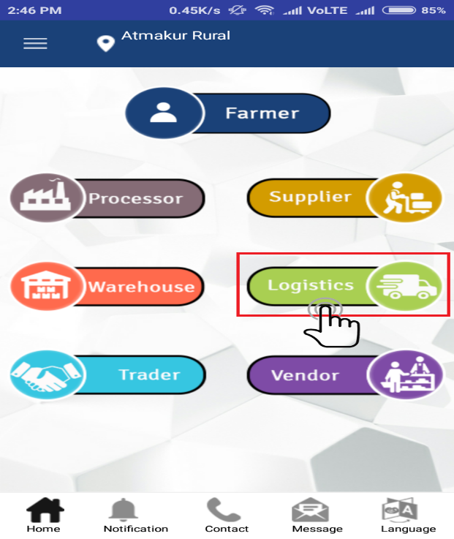

After click the Icon Logistics it will navigate to the mobile number pop-up page so there you have to enter mobile number and then click submit

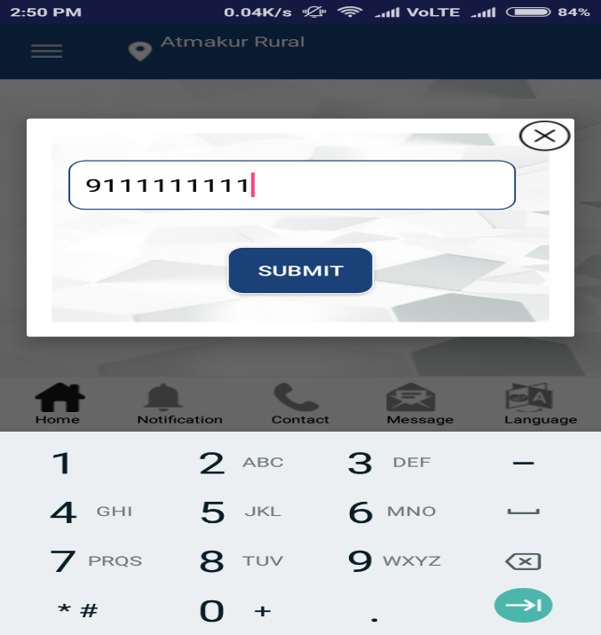

It will navigate to the registration form there you may all the mandate fields and valid information regarding in registration form

Here I can register as company in the Logistic registrations

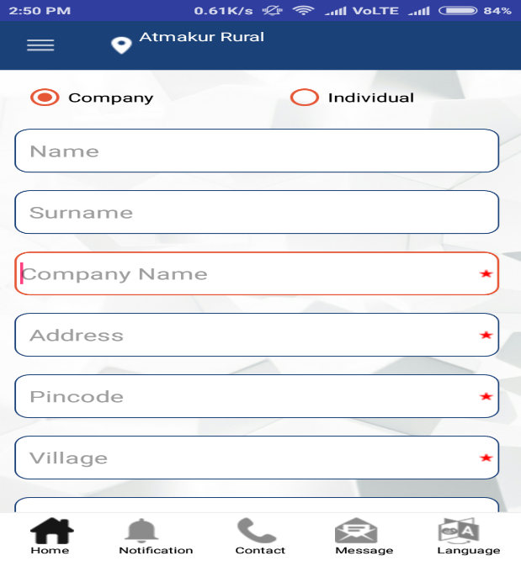

The registration form will continue screen…

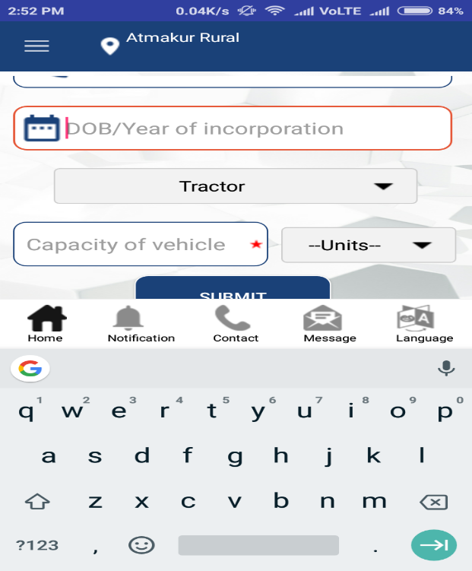

After complete all the mandate field and select vehicle type and enter capacity of vehicle and units are Quintal or Tones and then submit then you will receive a OTP and verify it automatically get a successful message “Registered Successfully”

Same process will continue in the registration Logistics as Individual

Now, we seen the registration of Trader. Please click the Trader Icon in the Agmarks tile page

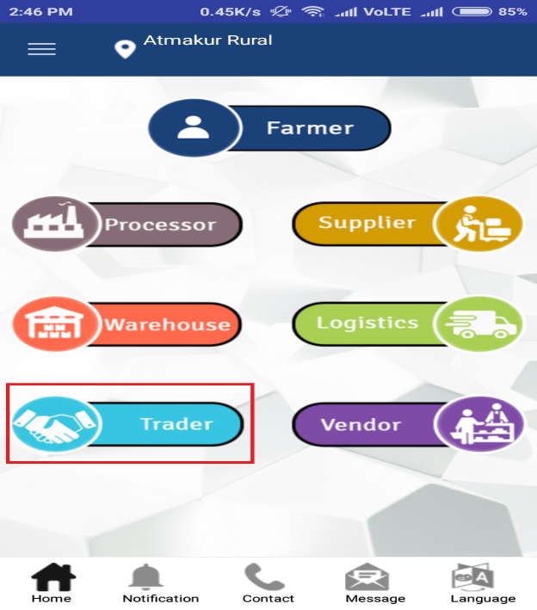

After click the Trader icon it will take to the one of the screen in the registration form there you have to enter the mobile number and then click submit



It will take you to next screen of registration form there you may fill all the valid and mandate fields and selectee’s in the limited like 5 crops,8 vegetables, 3 Animal Husbandry, 3 dairy these are autofill from the database and then submit.

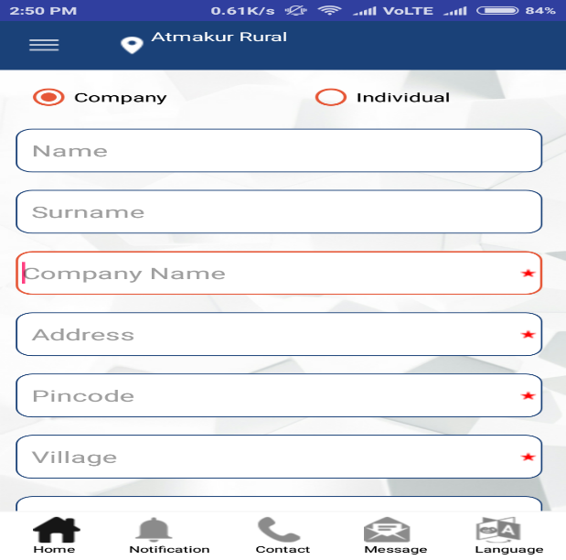

The registration form will continue screen…



Here you will receive a OTP and verify it automatically get a message when you submit all valid information is like “Registered Successfully”

Same process will continue in the Trader as Individual also please try this..

Last and final registration is **Vendor registration** take a look on this, please click on Vendor Registration Icon.

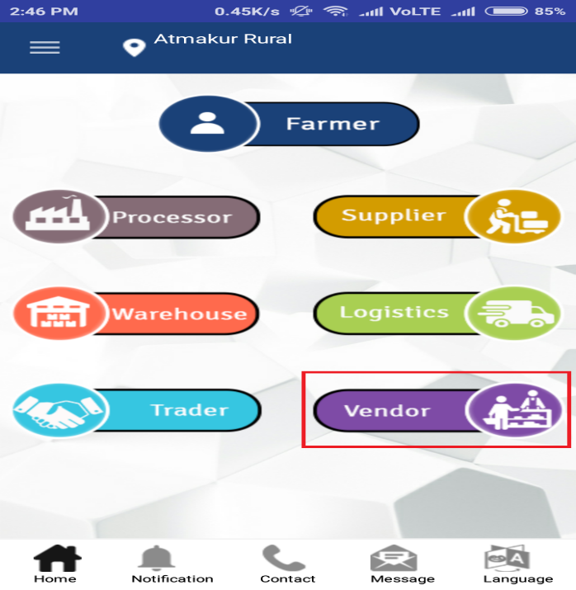

After click on the vendor registration icon it will navigate to one of the screen in registration of vendor there you have to enter mobile number and then submit.



If you enter valid mobile number and then it will navigate to the next screen of registration process



The registration form will continue screen…

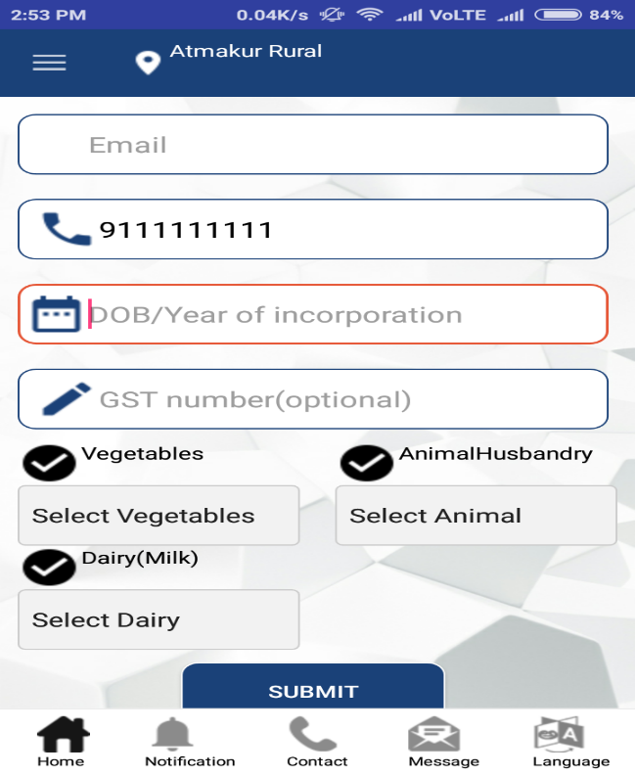

After filling all the mandate fields in the registration form and there three category’s like vegetables, Animal Husbandry, Dairy are respect items like 8 vegetables, 3 Animal Husbandry, 3 Dairy products and then click submit button there will receive OTP and verify it then automatically registered if valid information you have submit.

Same process will continue in the vendor registration as Individual also, please try this.

Note: One user can allows only four registrations only.